**SQL ASSIGNMENT 1**

**Submitted by:** Navyatha Godla

**Submitted on**: 05/02/2024.

**Task:** 1. Insert a new record in your Orders table.

**Code:**

Insert into Orders Values (5005,8530,103,'2024-02-03',3000)

Select * from Orders

**Result:**

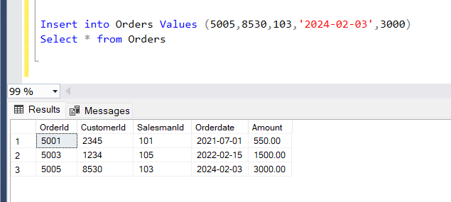

**Task:** 2. Add Primary key constraint for SalesmanId column in Salesman table. Add default constraint for City column in Salesman table. Add Foreign key constraint for SalesmanId column in Customer table. Add not null constraint in Customer_name column for the Customer table.

**Code:**

Alter table Salesman alter Column SalesmanId int not null;

Alter table Salesman add constraint Pk_Salesman_SalesmanId Primary Key (SalesmanId);

Alter table Salesman add constraint Pf_Salesman_city Default 'Texas' for City;

Alter table Customer with nocheck add constraint FK_SalesmanId Foreign Key (SalesmanId) References Salesman(SalesmanId);

Alter table Customer alter column CustomerName varchar(255) not null

**Results:**

**Task:** 3. Fetch the data where the Customer’s name is ending with ‘N’ also get the purchase amount value greater than 500.

**Code:**

Select * from Customer where CustomerName like '%N' and PurchaseAmount>500

**Result:**

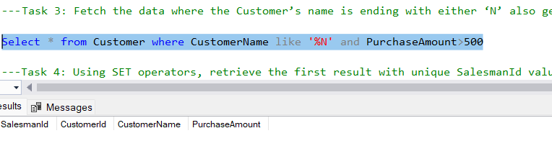

**Task:** 4. Using SET operators, retrieve the first result with unique SalesmanId values from two tables, and the other result containing SalesmanId without duplicates from two tables.

**Code:**

Select Top 1 SalesmanId from (Select SalesmanId from Salesman

Union select SalesmanId from Customer) as Cs;

Select SalesmanId from Salesman

Union select SalesmanId from Customer;

**Result:**

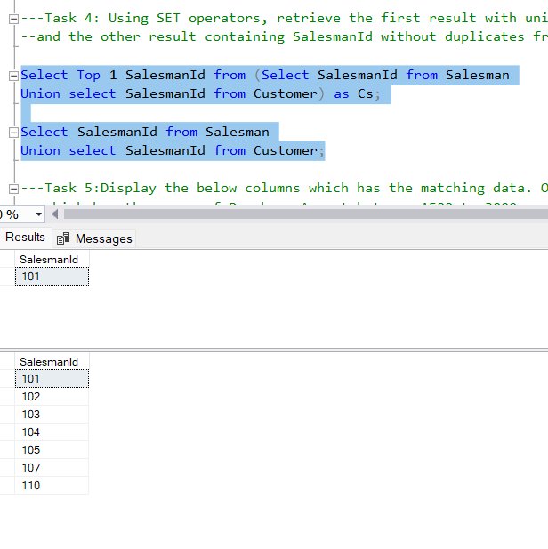

**Task:** 5. Display the below columns which has the matching data. Orderdate, Salesman Name, Customer Name, Commission, and City which has the range of Purchase Amount between 1500 to 3000.

**Code:**

Select o.Orderdate, s.Name as SalesmanName, c.CustomerName, s.Commission, s.city

from Orders o

join Salesman s on o.SalesmanId=s.SalesmanId

join Customer c on o.CustomerId=c.CustomerId

Where o.Amount between 1500 and 3000

**Result:**

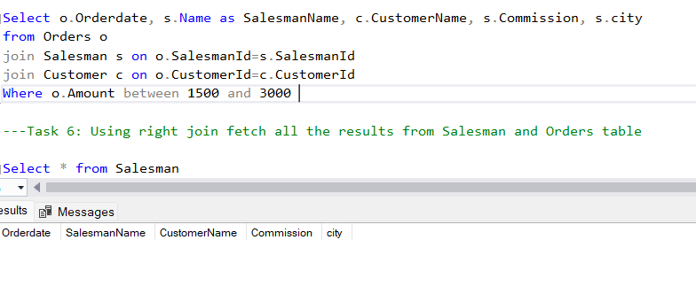

**Task:** 6. Using right join fetch all the results from Salesman and Orders table

**Code:**

Select * from Salesman

Right join Orders on Salesman.SalesmanId=Orders.SalesmanId;

**Result:**

